STEP 1 : BAT and SH File creation

To create a sh file open a fresh text file and save it as with .sh extension. In that file paste the below.

# To activate the python environment
source E:/ML_APIs/Python_Environment/python3.8.10_kollectcall/Scripts/activate
# To navigate to project directory
cd E:/ML_APIs/API/TeraKollect_call_preferredSessionV1
# To set the environment variables
source config/config.sh
# To run python application as background process
nohup python Kollect_preferredSession_app.py &
# Successful deployment
echo "ML Application deployed Successfully"
# To wait terminal for 5 sec
sleep 5s
# To logout and close the terminal
logout

Remember you need the prior experience in deploying things manually earlier. In below explained the above commands functionality

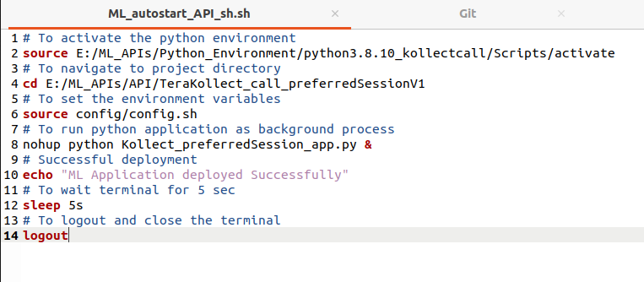
1) First we need to activate our environment. For that as per the windows deployment document we navigate to created environment first and then will activate it. Here we follow all together which means the same.

2 ) Navigate to project directory

3) To set the environment variable values in local

4) To run the python application as background process

5) For a success full deployment It will print the successful message

6) Terminal waits 5 seconds after the successful deployment since we need to check the successful deployment message to confirm ourself

7) To logout the session and close the the terminal

For reference purpose the above commands manipulated with sample directory. Note it will change as per the individual /server systems

Next is to create a bat file, open a fresh text file and save is as .bat extension & paste the below

@echo off

title ML_autostart_API

start "C:\Program Files\Git\git-bash.exe" ML_autostart_API_sh.sh

1) In title whatever title required name it.

2) In start mention the git-bash executable file path followed by the sh file created earlier, with the respective name

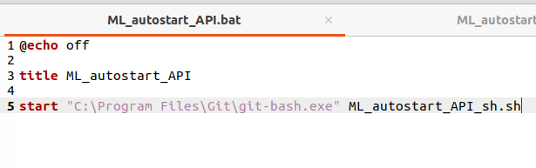

2) In start mention the git-bash executable file path followed by the sh file created earlier with the respective name. To find the executable file folder go to operating system drive and search for git
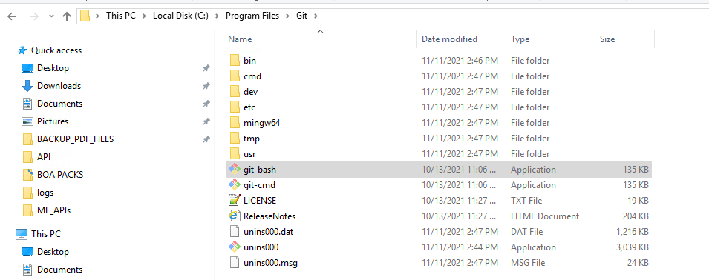

Remember both files should be in the same directory else it won’t work at all.

If you’re worrying to follow the commands in further deployments you may create the executable file using above guidance and by simply clicking the bat file execute the application further

STEP 2 : Automating In a system Startup

To automate the application in system startup do follow the bellow

1) Go to run using Winows+R or else search for run in windows start

2) Type shell:startup and press enter

3) It will open a specific folder in file explorer, Paste the both sh and bat file in that path now the above commands what we’ve done is automatically executed in system startup. In every restart we don’t need to start the application further

